**HO CHI MINH UNIVERSITY OF TECHNOLOGY AND EDUCATION**

**FALCUTY FOR HIGH QUALITY TRANING**



**Lecturer: Mr. Nguyen Duc Khoan**

**FINAL PROJECT**

**TOPIC: ONLINE SHOPPING STORE**

**ATTENDEES:**

**TRAN THANH HIEN -**

**NGUYEN DUY HIEU -**

**LE MINH QUANG – 17110063**

**SEMESTER: 1 – SCHOOL YEAR: 2019 – 2020**

**HO CHI MINH CITY – 11.2019**

**TABLE OF CONTENTS**

**CHAPTER 1: INTRODUCTION** 3

**1.1.** **Project target** 3

**1.2.** **Project range** 4

**1.3.** **Technology used** 4

**CHAPTER 2: USECASE** 4

**CHAPTER 3: CLASS DIAGRAM** 6

**CHAPTER 4: ERD AND DATABASE DIAGRAM** 8

**CHAPTER 5: SCREENSHOT** 10

**1.** **Login and Register** 10

**2.** **Products** 11

**CHAPTER 4: SUMMARY** 13

**2.1.** **The advantages and disadvantages of the project** 13

**2.1.1.** **The advantages** 13

**2.1.2.** **The disadvantages** 13

**WORK ASSIGNMENT** 13

**REFERENCES** 16

**PREFACE**

To make any project, essential requirement is able guidance and references without which project is incomplete. We are very much thankful to Mr. Nguyen Duc Khoan who has provided us an opportunity and motivation to gain knowledge through this type of project. We will get practical knowledge from this project and this will help us a lot in our career.

The present is not free of limitation. There might have problem regarding lack of limitation in some aspects and also some minor mistakes such as typing mistakes. I apologize if any error is found which was deliberately made. Please feel free to contact me if any question arises.

Thank you!

***COMMENT OF THE INSTRUCTOR***

.........................................................................................................................................................................................................................................................................................................................................................................................................................................................................................................................................................................................................................................................................................................................................................................................................................................................................................................................................................................................................................................................................................................................................................................................................................................................................................................................................................................................................................................................................................................................................................................................................................................................................................................................................................................................................................................................................................................................................................................................................................................................................................................................................................................................................................................................................................................................................................................................................................................................................................................................................................................................................................................................................................................................................................................................................................................................................................................................................................................................................................................................................................................................................................................................................................................................................................................................................................................................................................................................................................................................................................................................................................................................................................................................................................................

INSTRUCTOR

# 

# **CHAPTER 1: INTRODUCTION**

## **Project target**

Online shopping is the mechanism by which retailers that sell on the internet purchase goods and services, so people can buy just about anything from companies that supply their products online. Online shopping is an e-commerce type. E-commerce or Digital Commerce, a type of E-Business (a company that makes all or most of its Internet transactions), is the acquisition, selling and exchange of goods and services through computer networks (such as the Internet) through which electronic transactions or terms of sale are carried out.

Our target is developing a website to provide customers a system that can help them to buy stuffs easily without going outside.

## **Project range**

An online shopping store with various products and category. A person who wants to buy is a lifestyle e-commerce web application via online shopping, retailing various products of fashion and lifestyle.

* 1. **Technology used**

We use ASP.NET MVC to design this website. Connect to Microsoft SQL Server, interact with databases, executing queries,…

# 

# **CHAPTER 2: USECASE**

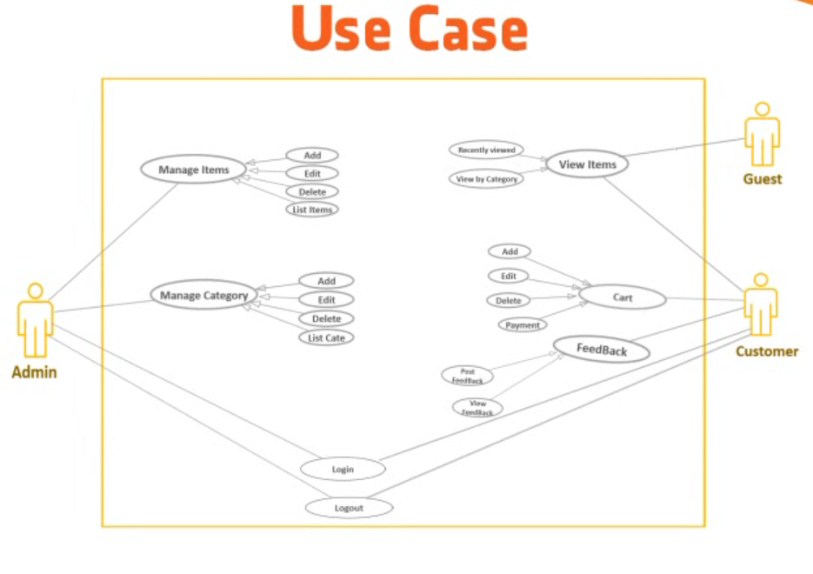

Our Usecase includes 3 objects: Admin, Guest and Customer. Admin can manage items and manage category, while Guest and Customer can view items but only Customer can add product to cart and give feedback.

There are also login and logout function in our website.

# **CHAPTER 3: CLASS DIAGRAM**

The purpose of the diagram is to introduce some common terms, "dictionary" for online shopping - Customer, Web User, Account, Shopping Cart, Product, Order, , etc. and relationships between. It could be used as a common ground between business analysts and software developers.

Each customer has unique id and is linked to exactly one **account. Guest can register as a web user to be able to buy item.** Web user has login name which also serves as unique id

# **CHAPTER 4: ERD AND DATABASE DIAGRAM**

* 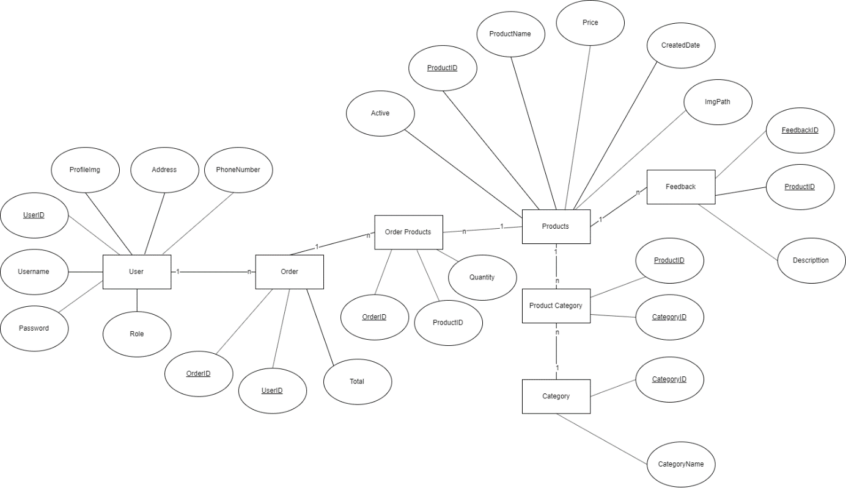Entity Relationship Diagram

There are 5 main entities: User, Order, Category, Products and Feedback. The User table includes UserID, Username, Password, ProfieImg, Address, PhoneNumber,… as attributes.

* Database Diagram

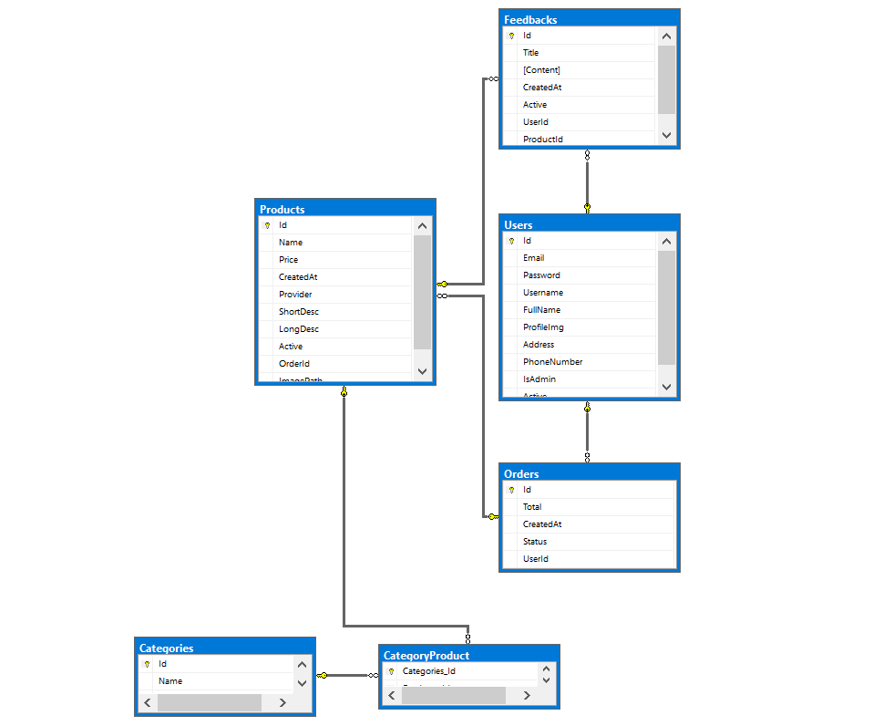

# **CHAPTER 5: SCREENSHOT**

1. 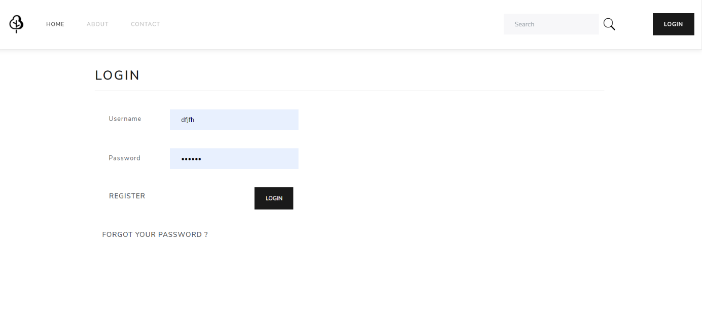**Login and Register**

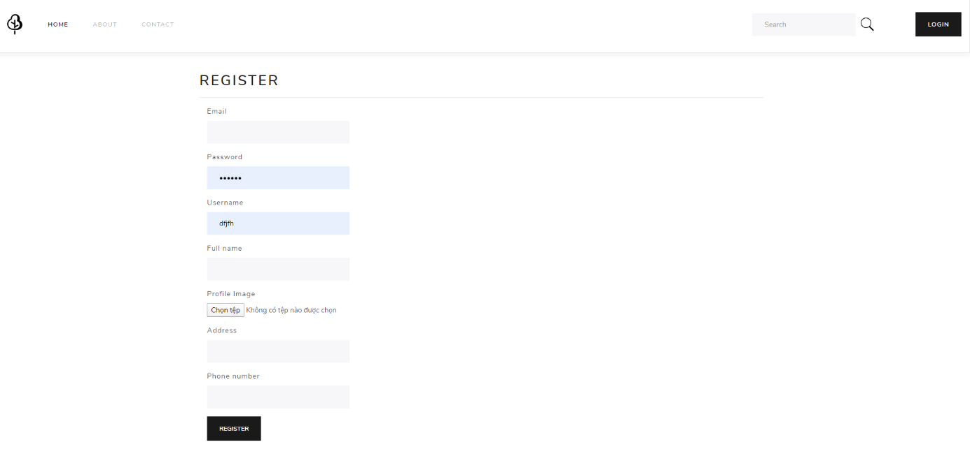This is our Login page.

This is our Register page

1. 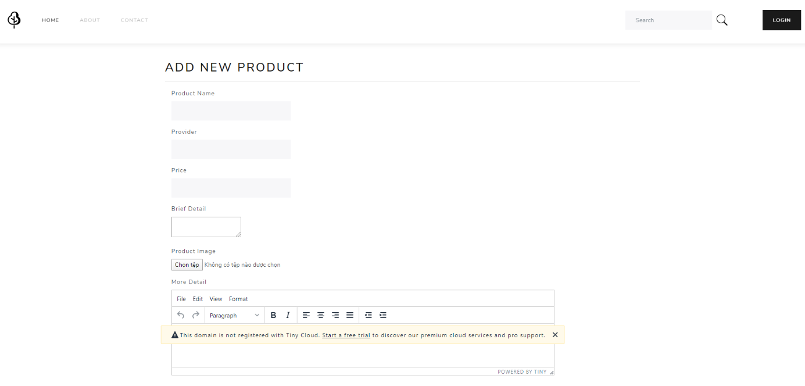**Products**

This is our add Product page.

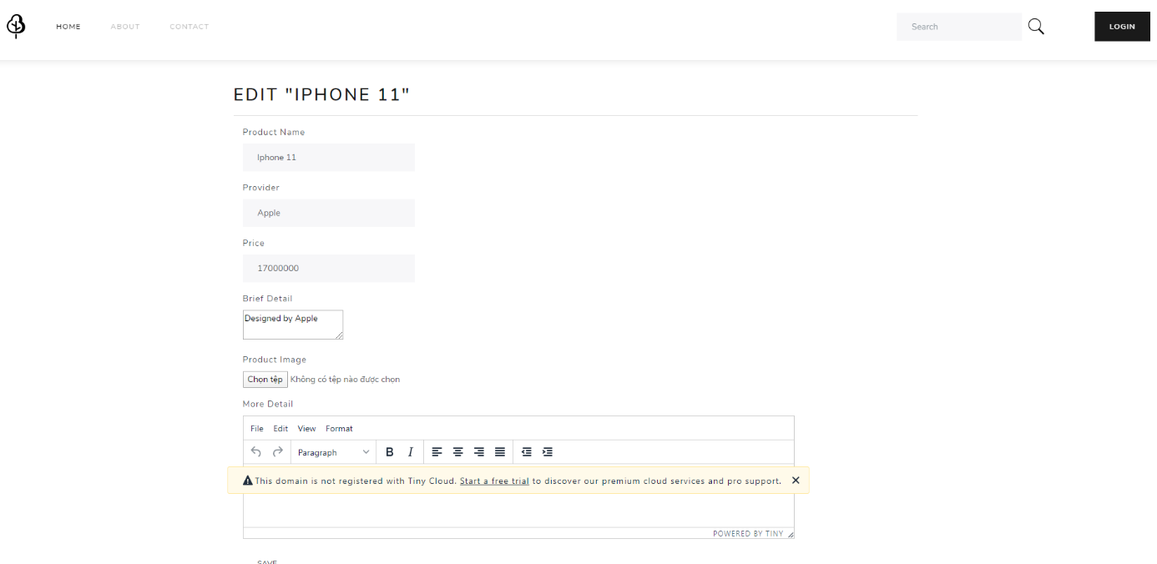

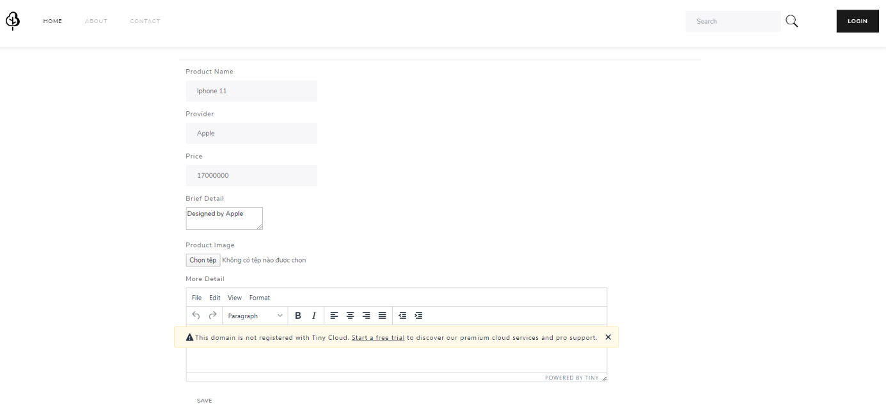Edit Product page.

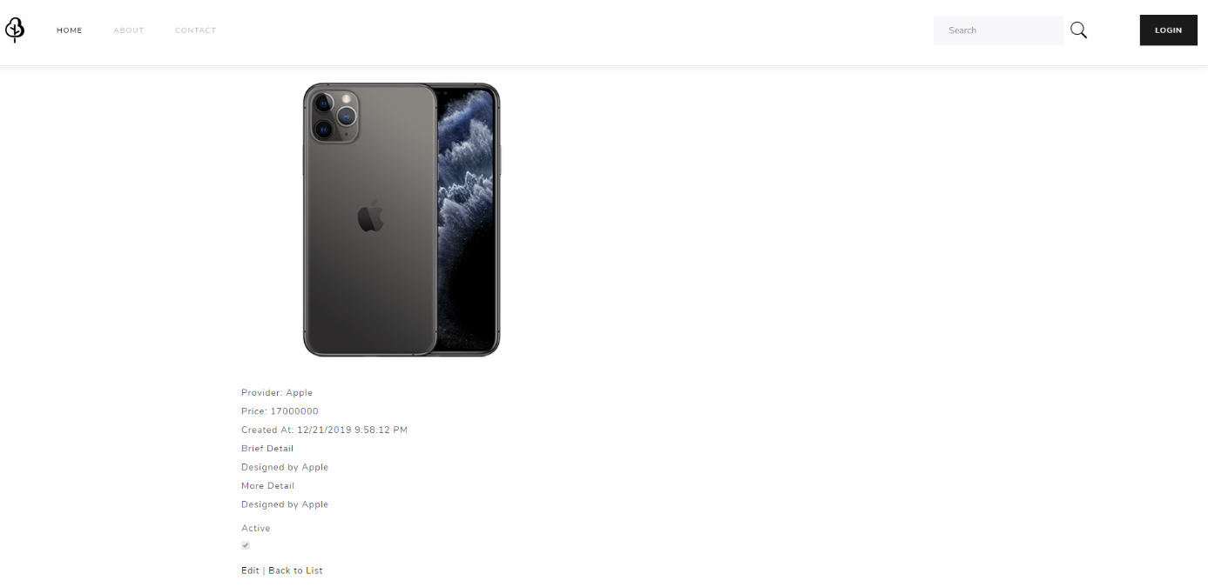

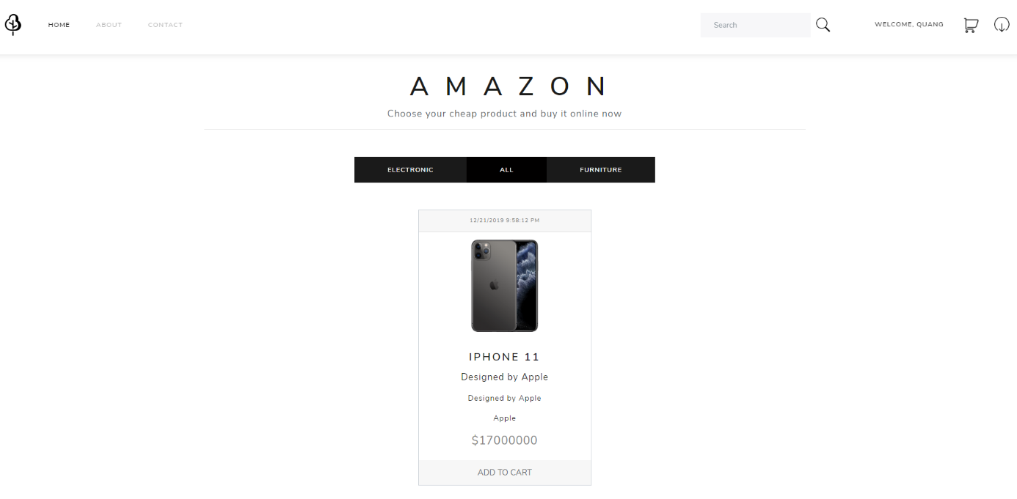Detail Product page.

This is the homepage

1. **Category**

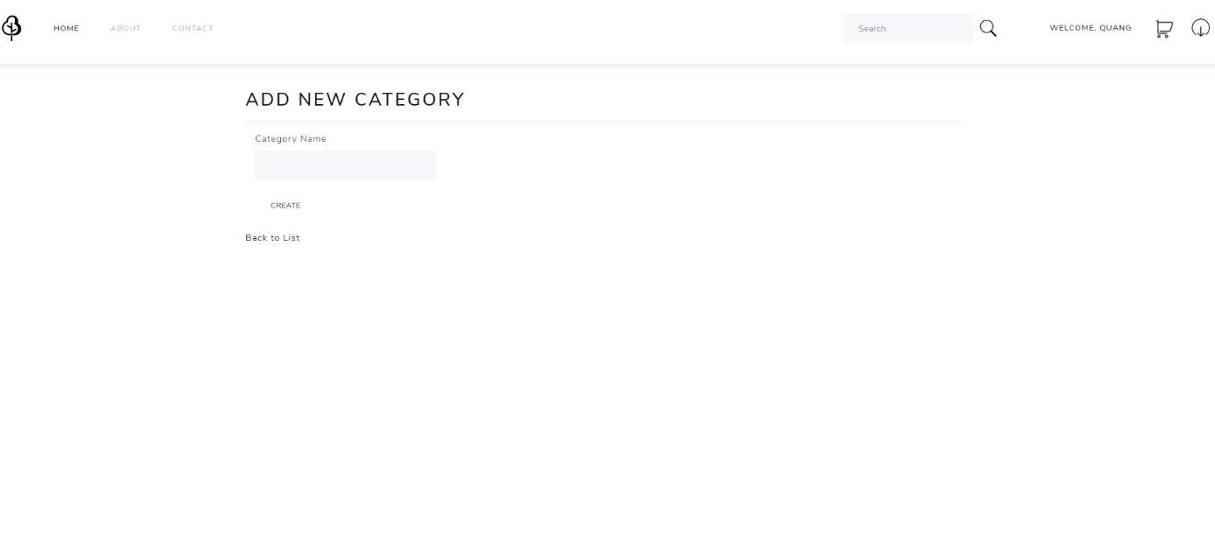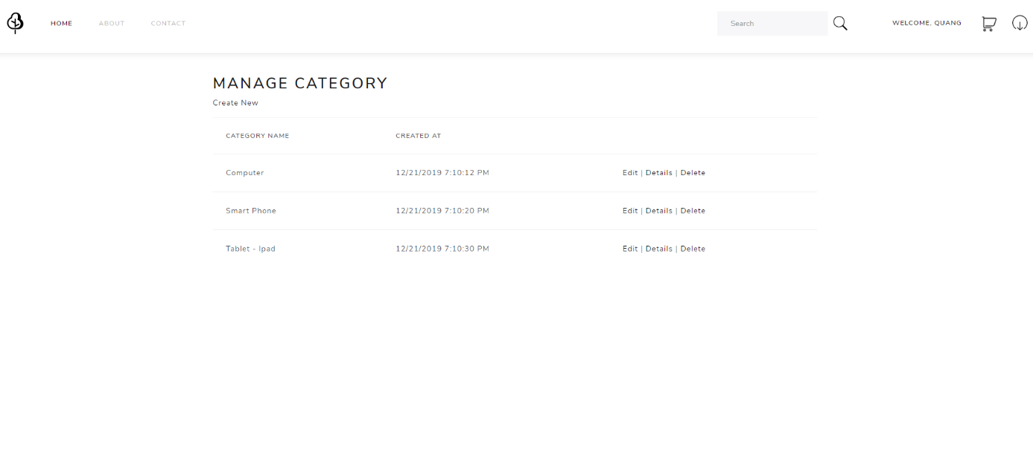Main page of Category

Add Category.

# **CHAPTER 4: SUMMARY**

* 1. **The advantages and disadvantages of the project**
     1. **The advantages**

We have made a project that had an easy-to-use UI so the users will face no obstacles to use this program. Besides that, the code is quite clean and clear.

* + 1. **The disadvantages**

The algorithms are not completely optimized. Some bugs still occur when we run the program in some specific test cases. We plan to build this program to be more efficient.

# **WORK ASSIGNMENT**

|  |  |  |  |  |  |  |
| --- | --- | --- | --- | --- | --- | --- |
| **Week** | **Job** | **Time** | **Product** | **Attendee** | **Completion day** | **Rate** |
| 1  From  25/11/2019  To  01/12/2019 | 1. Find references | 25/11 | - Planning tasks | All members | 25/11 | 100% |
| 2. Planning | 26/11 |  | All members | 26/11 | 100% |
| 3. Work assignment | 28/11 |  | Leader: Nguyễn Duy Hiếu | 28/11 | 100% |
| 4. First part of the report | 29/11 – 30/11 | - Complete the first part of the report | - Lê Minh Quang | 30/11 | 100% |
| 5. Design UI | 1/12 | - Complete the User Interface of the Program | - Trần Thanh Hiên | 1/12 | 100% |
| 2  From  2/12/2019  To  8/12/2019 | 1. Complete general UI, Menu, Buttons, Logo, Icon | 2/12 -4/12 | - General UI full of buttons | - Lê Minh Quang | 4/12 | 100% |
| 2. Generate necessary properties, function | 5/12-6/12 | - Login, Register | - Nguyễn Duy Hiếu | 6/12 | 100% |
| 3. Build Add, Edit, Delete function | 6/12 – 8/12 | - For Products and Category | - Trần Thanh Hiên | 8/12 | 100% |
| 3  From  9/12/2019  To  15/12/2019 | 1. Testing | 9/12 – 12/12 | - Try some test cases | Lê Minh Quang | 12/12 | 100% |
| 2. Make report for the main contents (P1) | 13/12-14/12 | - Report for first part | - Lê Minh Quang | 14/12 | 100% |
| 4  From  16/12/2019  To  21/12/2019 | 1. Complete remaining parts | 16/12 – 18/12 |  | - All members | 18/12 | 100% |
| 2. Complete some functions | 18/12-19/12 |  | - Nguyễn Duy Hiếu | 19/12 | 100% |
| 3. Make report for the main contents (P1) | 19/12 |  | - Trần Thanh Hiên | 19/12 | 100% |
| 4. Testing | 20/12 |  | - All members | 20/12 | 100% |
| 5  21/12/2019 | 1. Adding some sub functions | 21/12 |  | - Nguyễn Duy Hiếu |  | 100% |
| 2. Do the last part of the report | 21/12 |  | - Trần Thanh Hiên |  | 100% |
| 4. Complete program, review the report | 21/12 |  | - All members |  | 100% |

# **REFERENCES**

[*https://www.w3schools.com/sql/sql_distinct.asp*](https://www.w3schools.com/sql/sql_distinct.asp)

[*https://docs.microsoft.com/en-us/dotnet/csharp/how-to/search-strings*](https://docs.microsoft.com/en-us/dotnet/csharp/how-to/search-strings)

[*https://www.c-sharpcorner.com/UploadFile/1e050f/insert-update-and-delete-record-in-datagridview-C-Sharp/*](https://www.c-sharpcorner.com/UploadFile/1e050f/insert-update-and-delete-record-in-datagridview-C-Sharp/)

[*https://bootswatch.com/*](https://bootswatch.com/)